POS Screen-Header

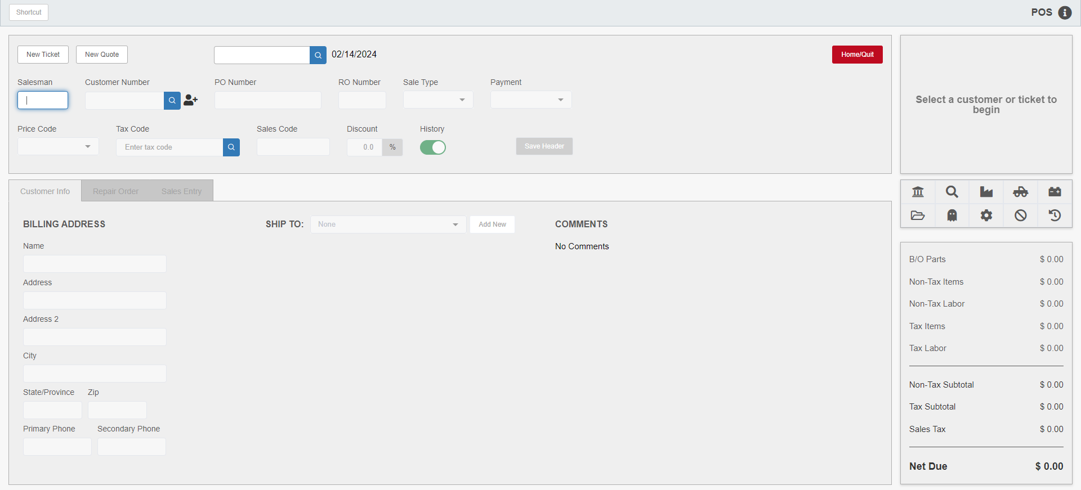

Point Of Sale Invoicing (POS) lets you create picking tickets, quotes, and sales invoices for a variety of transactions, like customer parts sales, repairs to dealership equipment, repairs to customer equipment, or even unit sales.

To access this function, you can either:

- Select “Parts Point Of Sale” from the menu.
- Type “POS” into the Shortcuts Bar.

When opening a new picking ticket with POS, the system automatically assigns a picking ticket number. Once you write a picking ticket, the picking ticket is converted to a sales invoice and assigned an invoice number.

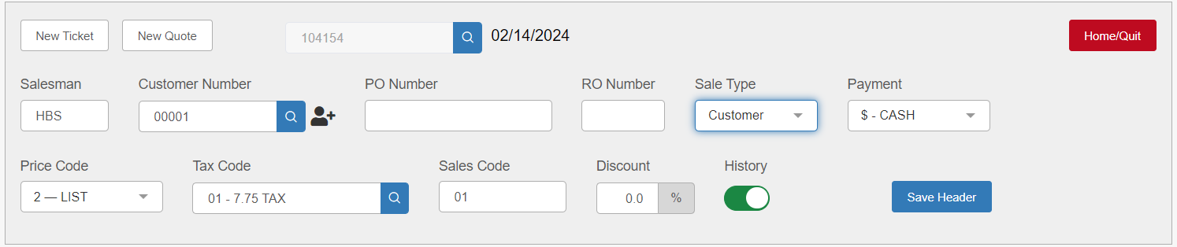

Header Fields:

New Ticket: Click this button at any time to clear the header and start a new picking ticket.

New Quote: Click this button at any time to clear the header and start a new parts quote.

Picking Ticket #: This field shows the system-assigned picking ticket number. The system auto-fills this field when a new ticket is begun. You may also enter a picking ticket number here to access an existing ticket, or click on the Search icon to the right of the field to search for existing tickets.

Date: When a picking ticket is active on the screen, this date shows when the ticket was opened. Otherwise, it displays the current date.

Salesperson: This field holds the initials or number of the employee who opened the picking ticket. If you have a Salesperson database as part of your system, you can select the employee identifier from a drop-down menu. Otherwise, type the salesperson’s identifier (generally their initials) in the field.

Customer #: This field holds the 5-digit customer number. The number can be typed in or searched.
If you need to add a new customer, click the New Customer  icon next to the field. The system will automatically open Custom Customer Maintenance (CCM) to let you create the customer.

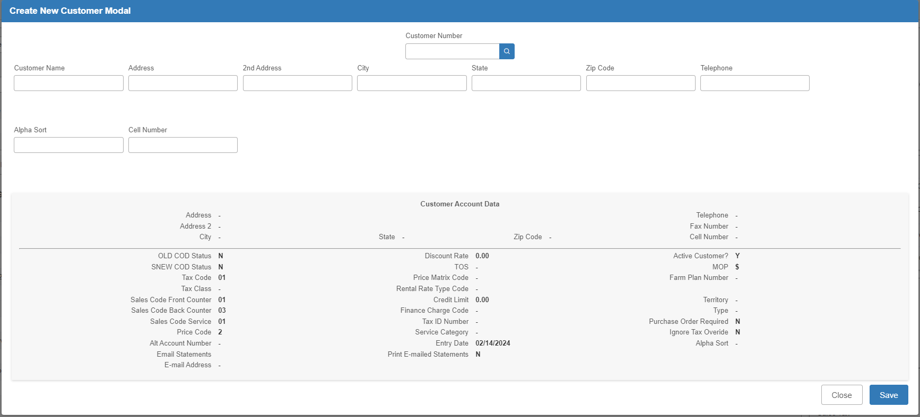

If you have the proper setting turned on in Finance Charge Rates & A/R Info (AIFC), the system will auto-generate a new customer number for you. Otherwise you will need to manually enter the new number. If you happen to type in a number that already exists, it will trigger the Customer Search, thereby letting you know and stopping you from creating a potential duplicate.

PO #: This field optionally holds a customer’s purchase order number. Change a customer’s setting in the Customer master (ECI) to require an entry in the field for each of their picking tickets.

RO #: For shop tickets, this field holds a repair order number. An entry here is required to identify the ticket as a repair order.

Sale Type: This field indicates “who” is going to pay for this invoice: Customer, Internal, Warranty, or Other.

- If a customer is paying for this invoice, choose Customer.
- If it is an internal ticket/repair order, choose Internal.
- If it is a warranty ticket, choose Warranty.
- The Other choice is most commonly used for a second type of Internal sale.

Payment: This field indicates how the ticket will be paid. The drop-down menu shows the choices for the customer selected on the ticket. It can include Cash, any of the different credit cards/credit plans, Accounts Receivable (AR Charge), and any other methods defined in the system. The field pre-fills with a default based on the selected customer’s record in Enter Customer Information (ECI), but can be changed as needed. In most cases, the method of payment may also be changed while finalizing the ticket.

Price Code: The selected customer’s default price code is displayed here, but can be changed as needed by selecting a different code from the dropdown menu.

Tax Code: This field displays the tax code for this ticket. The field auto-fills with the customer’s default from the Tax Code field in ECI, but can be changed. You can also look up available tax codes using the Search icon attached to the field:

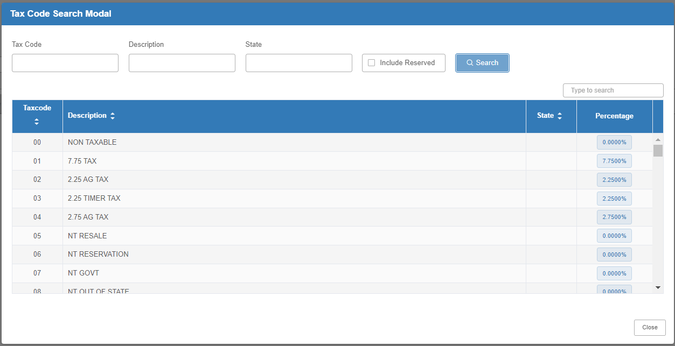

Sales Code: This field displays the sales code used for this ticket. The value filled for the customer from ECI is based on the details in the Header.

Discount: This field displays the percentage of any standard discount for this ticket. It fills with any value found for the customer in the Discount Rate field in ECI. These discounts apply to all pre-priced items.

History: This option is turned on by default and will record history for all parts entered on the ticket. Turn it off if you do not want to show sales history for the parts on this ticket.

Save Header: Click this button to save the header and continue with the ticket.

Home/Quit: Use this button to safely exit POS at any time without causing a document lock on any tickets or quotes you may have been working on. We recommend that you always click this button to exit POS rather than close the browser tab.

